Answer 2
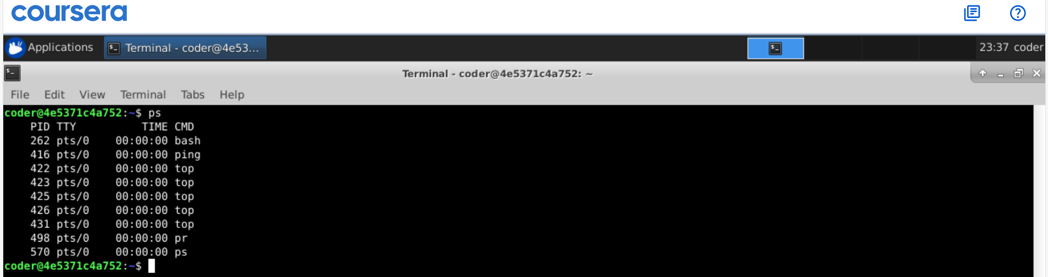
Explanation: By using the ps command from my user name I can get the all the process currently running under my username.

